Step by step on how to run the program on windows

1.
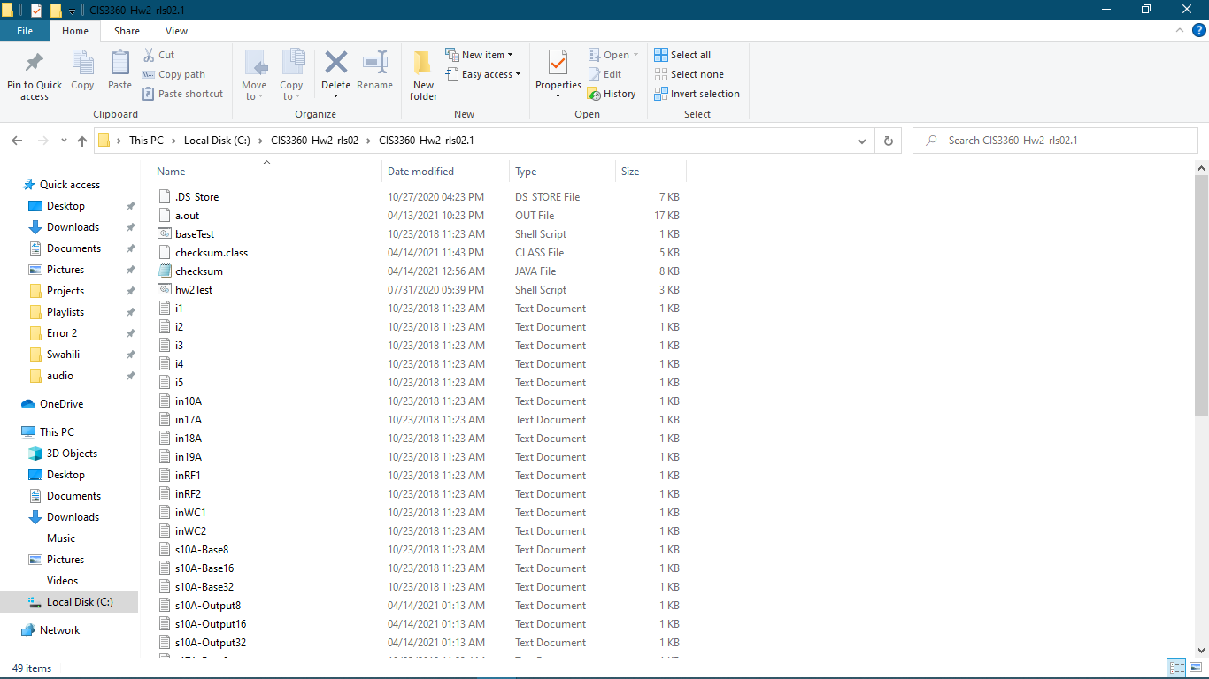
2. Copy the path to folder with checksum.java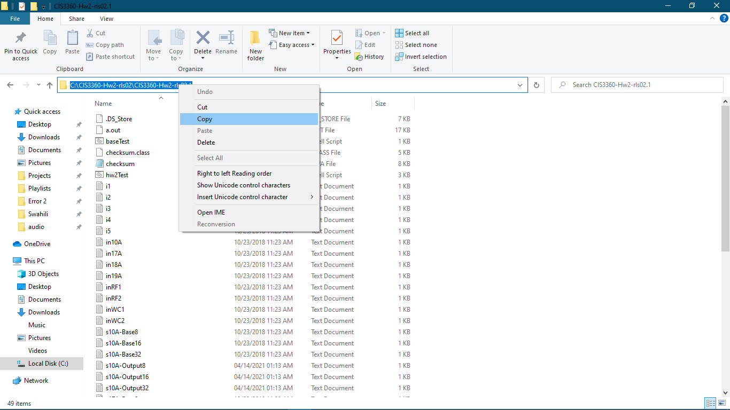
3. Open cmd
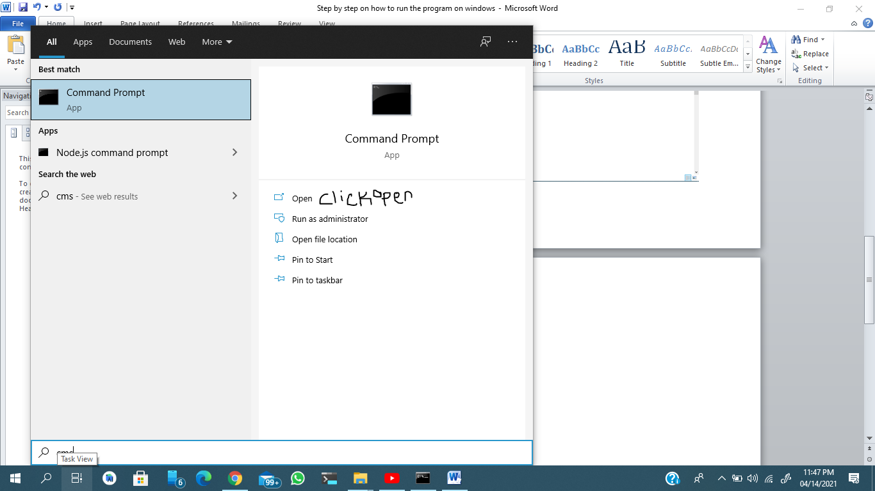
4. Type cd C:\CIS3360-Hw2-rls02\CIS3360-Hw2-rls02.1 as shown below in cmd
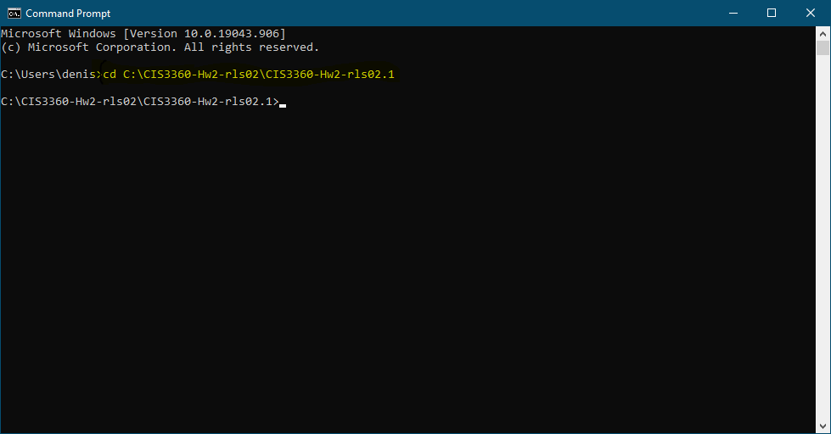

5. Make your java script executable by typing javac checksum.java
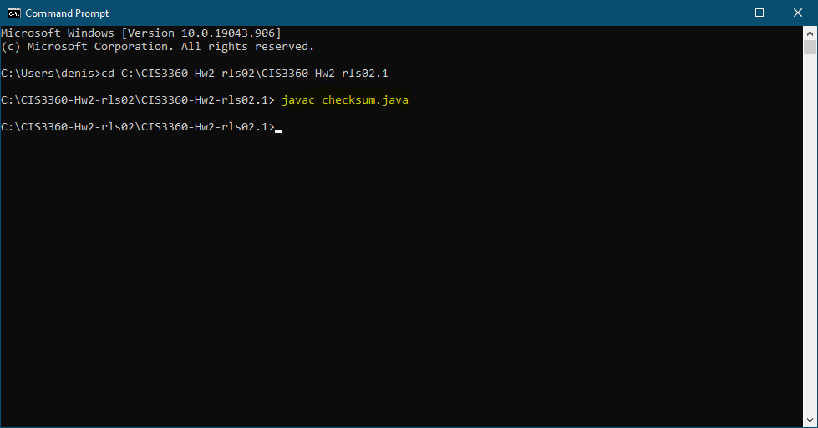
6. You java script is now excutable you can go ahead and run java checksum inputfile1.txt 8
7. For further test you can run bash hw2Test.sh checksum.java
Or
8. bash baseTest.sh checksum.java

